Text S2: Corrected projections algorithm
The corrected projections algorithm (CPA) is a method for identifying the dictionary elements that are present in an auditory scene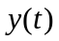. The method is based on constructing an estimate 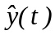 that minimizes the error between and in the least mean square sense for T observations of the signal , t=1,..,T. To obtain the estimate, we try to fit parameters 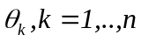 according to the model
S2. 1
The weighting factors of the dictionary elements 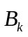consist of the scalar products 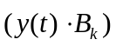 and the parameters 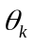 that minimize the error. The projections 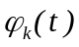 of the vector 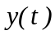 into the dictionary elementare then defined as a vector in the direction of the dictionary element, whose magnitude is proportional to the scalar product,
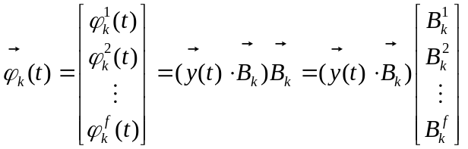S2. 2
To simplify notation, we arrange the T observations and the T estimates into (T x f)-dimensional column vectors:
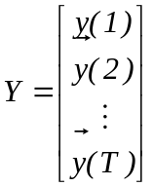 and 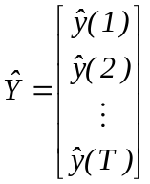S2. 3
If we then arrange the projections into a (T x f) by n matrix
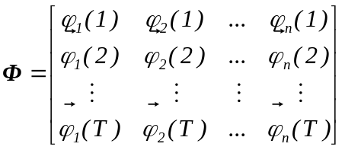S2. 4
and write the factors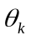 as an n-dimensional column vector called 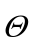
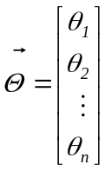S2. 5
then the estimate is given by the matrix multiplication:
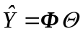S2. 6
We would like to find the vector that will minimize the mean square error between the observation Y and the estimate . This is a linear least squares problem.
The vector can be calculated by (Astrom and Wittenmark 1995):
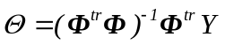 S2. 7
under the condition that the matrix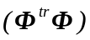has an inverse. For most practical purposes, the matrix is invertible, as we will show next.
The elements of matrix are as follows:
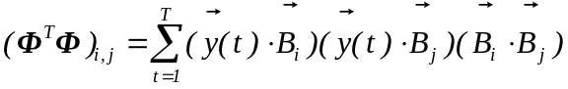 S2. 8
When the number of dimensions f of the signal is large, then the dot products
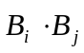, if 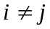. S2. 9
are small (see Text S4 for more details). Therefore, the matrix is almost diagonal because the off-diagonal elements depend on this very small value. The inverse of a diagonal matrix exists if the diagonal elements are not zero. The diagonal elements are given by:
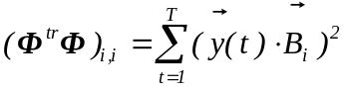 S2. 10
Therefore, for the inverse to exist, it is also necessary that the vectors considered 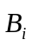 are not orthogonal to all the T samples of the signal , that is, for a given vector :
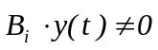 S2. 11
for at least one of the samples t=1,..,T.
Nevertheless, there are situations, e.g., 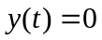 (a standard initial condition), in which the matrix does not have an inverse. In that case, we could use the solution
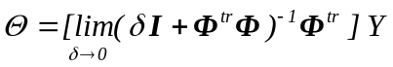S2. 12
where the brackets on the right-hand side denote the Moore-Penrose inverse of 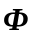and I is the unit matrix. The Moore-Penrose inverse exists even if the matrixhas no inverse. The equation S2.12 yields the solution, e.g., 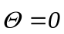 , in the case of .

Astrom, K. J. and B. Wittenmark (1995). "Adaptive Control, Second Edition." Prentice Hall.

